**Digital Image Processing Lab**

**CEL-445**

Lab Journal: 6



Name: Omar

Class: BCE-7(A)

# Enrollment No: 01-132182-024

**Objectives:**

* Image enhancement in frequency domain
* Low pass and High pass filters
* Point operations
* Image Contours

**Introduction:**

**Discrete Fourier Transform**

**Working with the Fourier transform on a computer usually involves a form of the transform known as the discrete Fourier transform (DFT). A discrete transform is a transform whose input and output values are discrete samples, making it convenient for computer manipulation. There are two principal reasons for using this form of the transform:**

* **The input and output of the DFT are both discrete, which makes it convenient for computer manipulations.**
* **There is a fast algorithm for computing the DFT known as the fast Fourier transform (FFT).**

**The DFT is usually defined for a discrete function  that is nonzero only over the finite region  and . The two-dimensional *M*-by-*N* DFT and inverse *M*-by-*N* DFT relationships are given by**

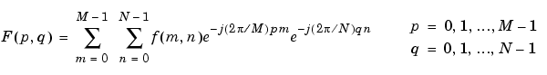

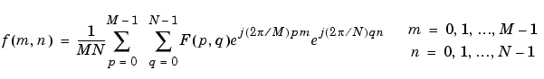

**The values  are the DFT coefficients of . The zero-frequency coefficient, , is often called the "DC component." DC is an electrical engineering term that stands for direct current. (Note that matrix indices in MATLAB always start at 1 rather than 0; therefore, the matrix elements f(1,1) and F(1,1) correspond to the mathematical quantities  and , respectively.)**

**The MATLAB functions fft,****fft2****, and fftn implement the fast Fourier transform algorithm for computing the one-dimensional DFT, two-dimensional DFT, and N-dimensional DFT, respectively. The functions ifft,****ifft2****, and ifftn compute the inverse DFT.**

**Relationship to the Fourier Transform**

**The DFT coefficients  are samples of the Fourier transform .**

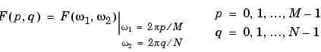

Task#1:Discrete Fourier Transform of an image

Code:

import cv2  
import numpy as np  
from matplotlib import pyplot as plt  
  
img = cv2.imread('R.jpg', cv2.IMREAD_COLOR)  
gray = cv2.cvtColor(img, cv2.COLOR_BGR2GRAY)  
cv2.imshow('gray',gray)  
cv2.waitKey(0)  
  
img_c2=np.fft.fft2(gray)  
plt.imshow(np.log(1+np.abs(gray)),"gray"),plt.title("Spectrum")  
  
  
img_c3=np.fft.fftshift(img_c2)  
plt.imshow(np.log(1+np.abs(img_c3)),"gray"),plt.title("Centered Spectrum")  
  
img_c4=np.fft.ifftshift(img_c3)  
plt.imshow(np.log(1+np.abs(img_c4)),"gray"),plt.title("Centered Spectrum")

Output:

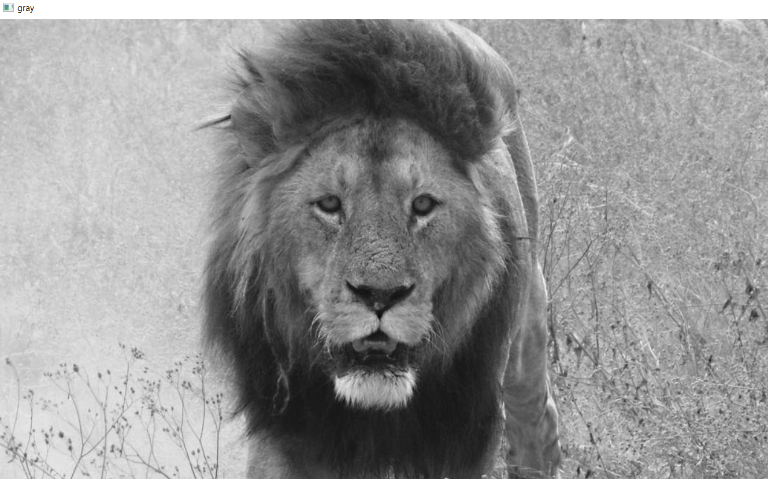

Task#2: Taking fourier transform and in processing apply Gaussian filters

import cv2  
import numpy as np  
from matplotlib import pyplot as plt  
  
## Gaussian Filters  
def distance (point1, point2):  
 return np. sqrt((point1[0] -point2[0])**2 + (point1[1] -point2[1])**2)  
def gaussianLP(DO, imgShape):  
 base = np.zeros(imgShape[:2])  
 rows, cols = imgShape[:2]  
 center = (rows/2,cols/2)  
 for x in range(cols):  
 for y in range (rows):  
 base[y,x] = np.exp(((-distance((y,x), center)**2)/(2* (DO**2))))  
 return base  
def gaussianHP (DO, imgShape):  
 base = np.zeros(imgShape[:2])  
 rows, cols = imgShape[:2]  
 center = (rows / 2, cols / 2)  
 for x in range(cols):  
 for y in range (rows):  
 base[y,x] = 1 - np.exp(((-distance((y,x), center)**2)/(2* (DO**2))))  
 return base  
  
img = cv2.imread("R.jpg", 0)  
original = np.fft.fft2(img)  
center = np.fft.fftshift(original)  
plt.figure(figsize=(6.4*5, 4.8*5), constrained_layout=False)  
plt. subplot (131), plt.imshow(img, "gray"), plt.title("Original Image")  
  
LowPassCenter = center * gaussianLP(50, img.shape)  
LowPass = np.fft.ifftshift (LowPassCenter)  
inverse_LowPass = np.fft.ifft2(LowPass)  
plt.subplot (132), plt.imshow(np.abs(inverse_LowPass), "gray"), plt.title("Gaussian Low Pass")  
  
HighPassCenter = center * gaussianHP(50,img.shape)  
HighPass = np.fft.ifftshift (HighPassCenter)  
inverse_HighPass = np.fft.ifft2(HighPass)  
plt. subplot (133), plt.imshow(np.abs(inverse_HighPass), "gray"), plt.title("Gaussian High Pass")  
  
plt.show()

Output:

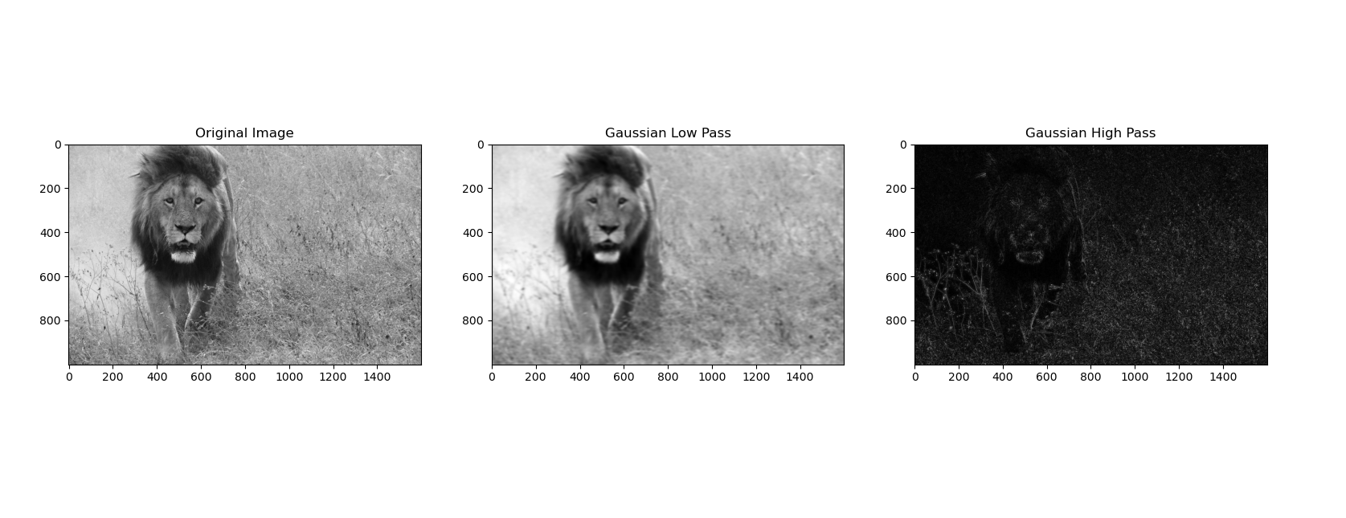

Task#3: Negative image

Code:

import cv2  
import numpy as np  
from matplotlib import pyplot as plt  
#Negative image  
# Read original image  
image = cv2.imread("R.jpg", 0)  
# Max intensity based on quantization .  
L = image.max()  
# Subtract each intensity from max to obtain negative -  
negative = L - image  
cv2.imshow('original', image)  
cv2.imshow('negative', negative)  
cv2.waitKey(0)  
cv2.destroyAllWindows()

Output:

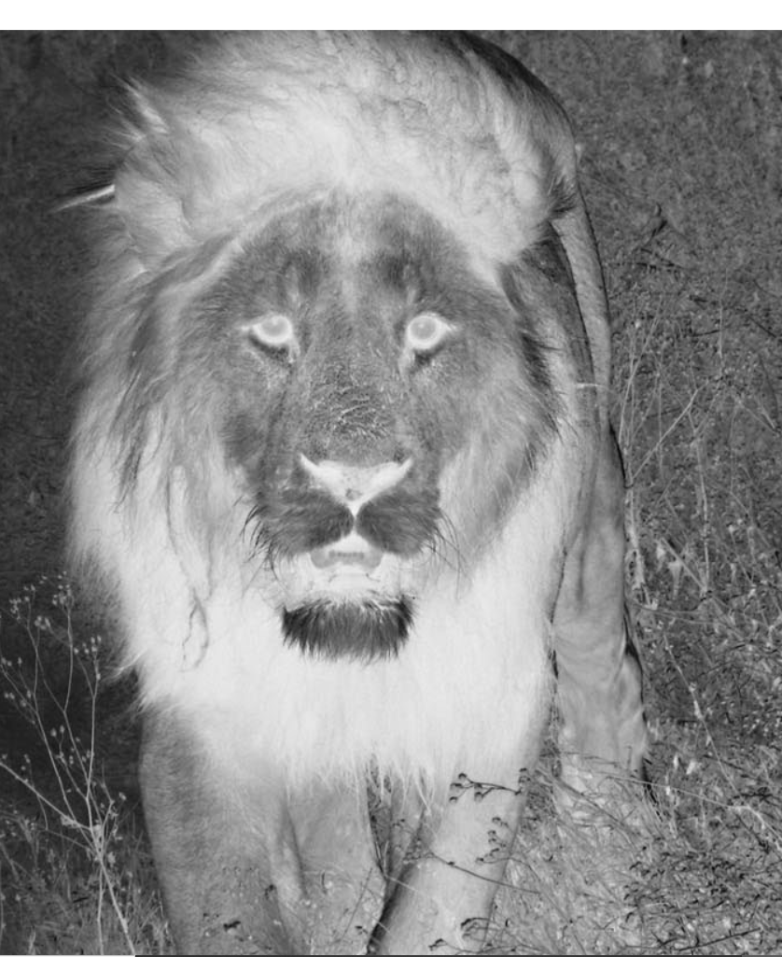

Task#4: Power law transformation

Code:

import cv2  
import numpy as np  
from matplotlib import pyplot as plt  
#Power law transformation  
#Open the image.  
image = cv2.imread("R.jpg", 0)  
# Sample gamma values to test  
for gamma in [0.2, 0.5, 1, 1.5, 1.8]:  
 # Apply gamma correction.  
 gamma_transformation = np.array(255*(image/255) ** gamma, dtype = 'uint8')  
 cv2.imshow('gamma transformed'+str(gamma)+'.jpg', gamma_transformation)  
 #agar output images write krwani hn to line11 main simply cv2.imwrite() lekh do  
cv2.waitKey(0)  
cv2.destroyAllWindows()

**Outputs:**

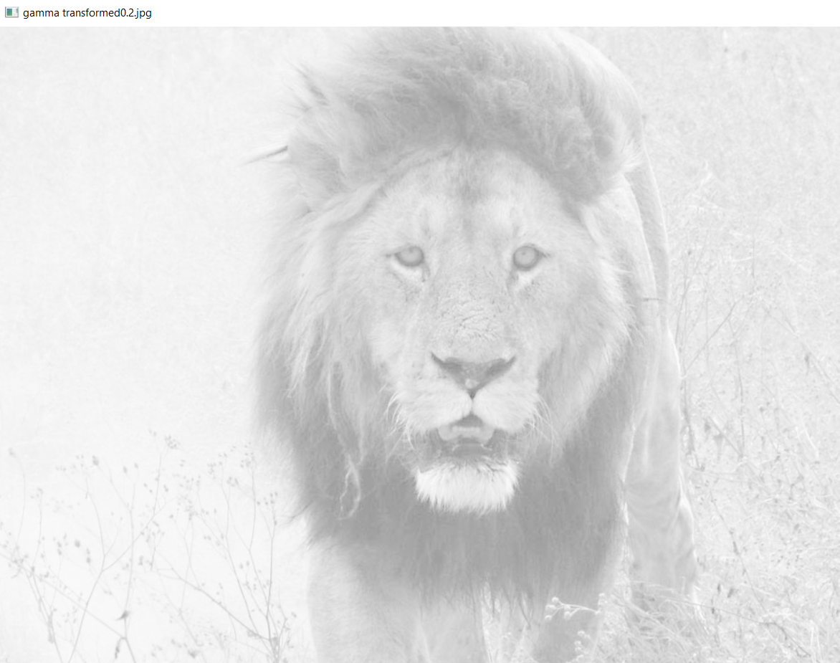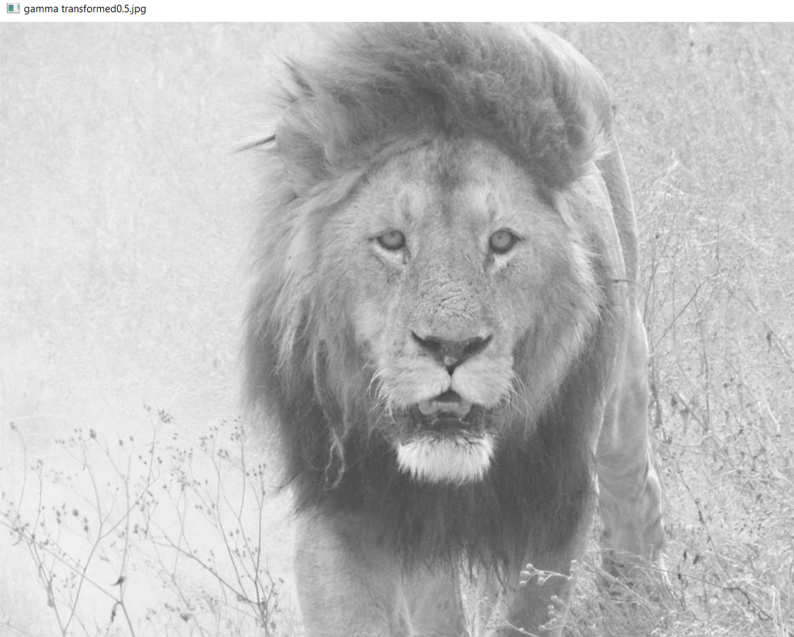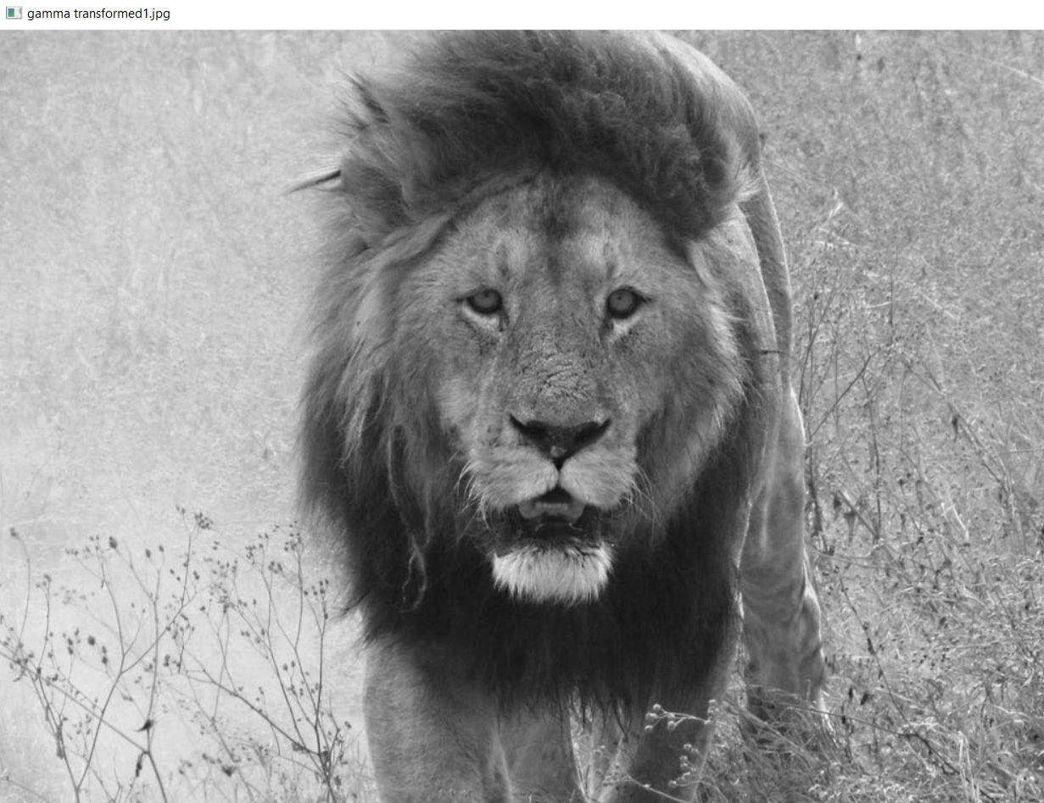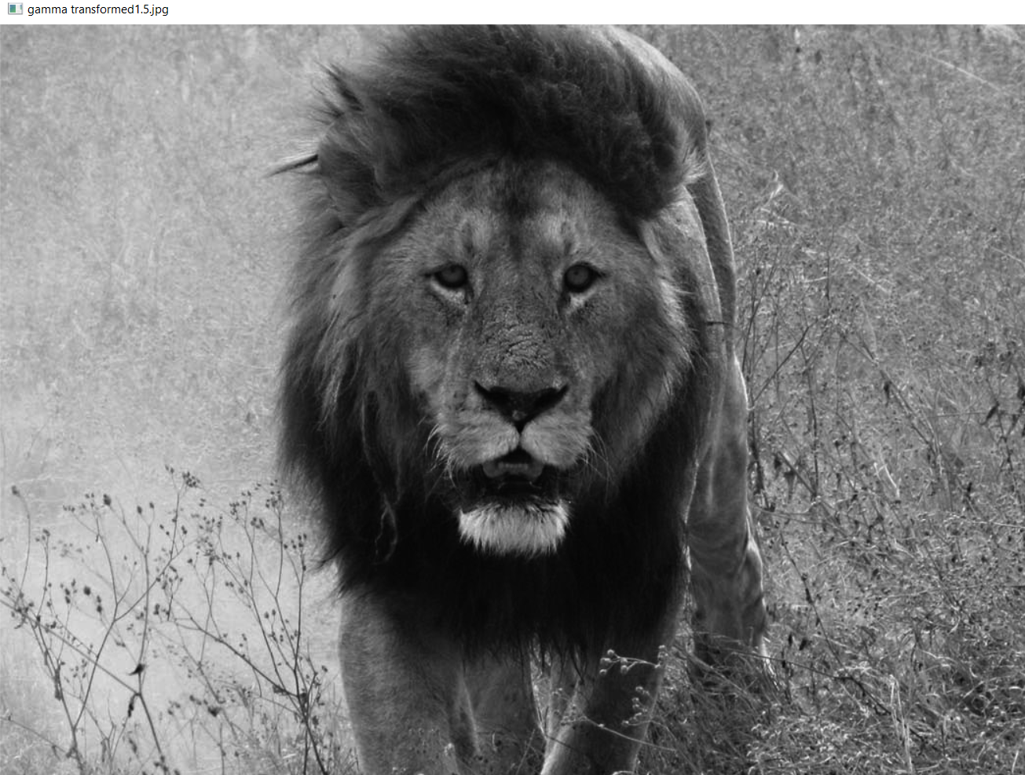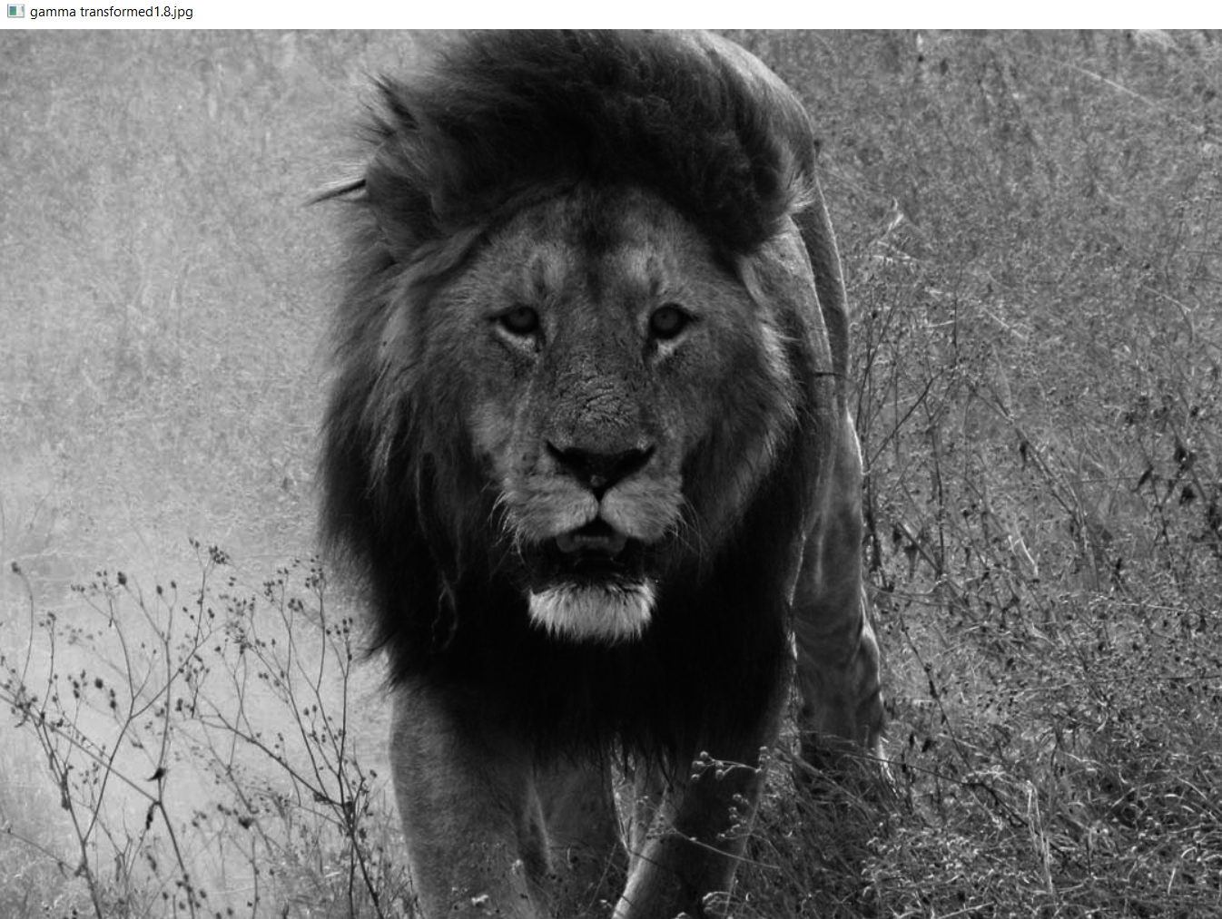

Task#5: Contours in images

Code:

import cv2  
import numpy as np  
from matplotlib import pyplot as plt  
######################Contours in images###############################  
# read the image  
image = cv2.imread("R.jpg",cv2.IMREAD_COLOR)  
# convert the image to grayscale format  
img_gray = cv2.cvtColor(image, cv2.COLOR_BGR2GRAY)  
# apply binary thresholding  
ret, thresh = cv2.threshold(img_gray, 150, 255, cv2.THRESH_BINARY)  
# visualize the binary image  
cv2.imshow('Binary image', thresh)  
cv2.waitKey(0)  
cv2.imshow('image', thresh)  
cv2.destroyAllWindows()  
  
  
# detect the contours on the binary image using cv2.CHAIN_APPROX_NONE  
contours, hierarchy = cv2.findContours (image=thresh, mode=cv2. RETR_TREE, method=cv2.CHAIN_APPROX_NONE)  
# draw contours on the original image  
image_copy = image.copy()  
cv2.drawContours(image=image_copy, contours=contours, contourIdx=-1, color=(0, 255, 0), thickness=2, lineType=cv2.LINE_AA)  
# see the results  
cv2.imshow('None approximation', image_copy)  
cv2.waitKey(0)  
cv2.imwrite('contours_none_image1.jpg', image_copy)  
cv2.destroyAllWindows()

Output:

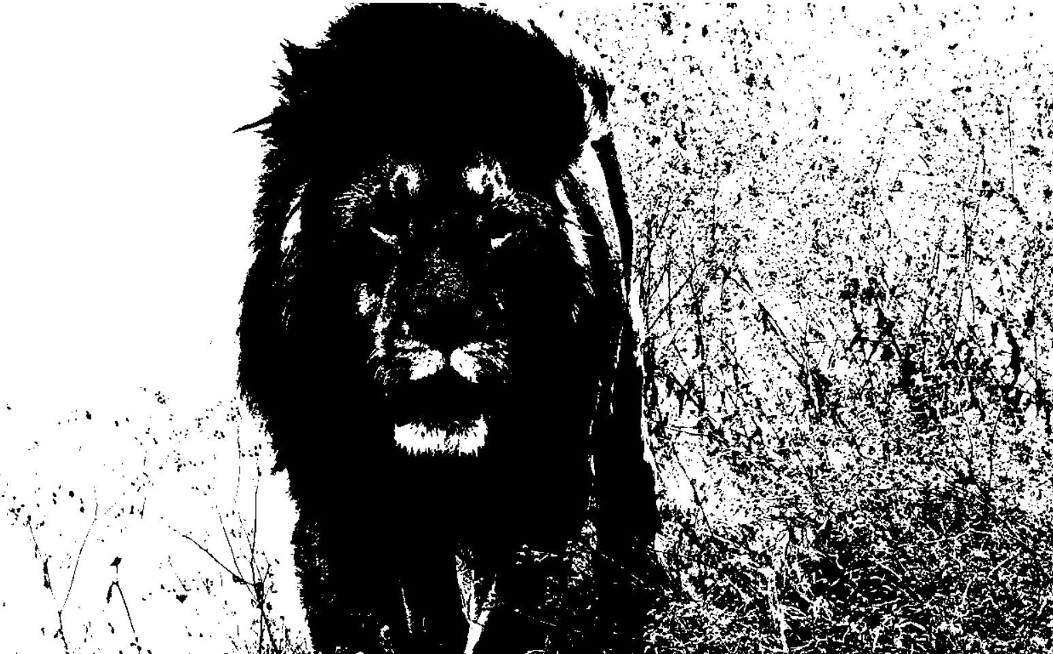

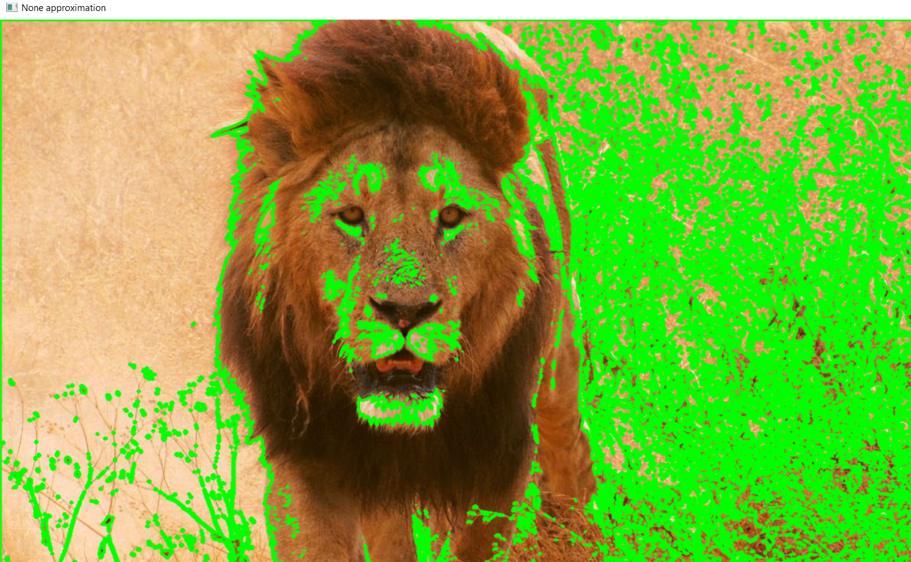

**Following output shows above contour image written to my hard-disk:**

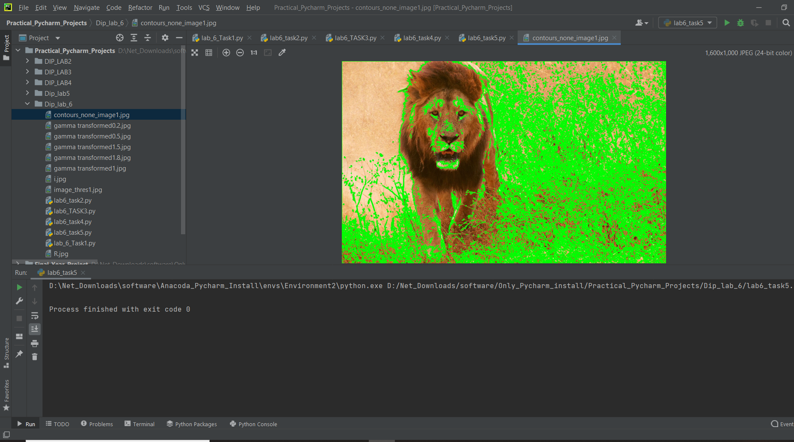

**Conclusion:**

In this lab we learned about Digital Image Processing and some of the functions that we can perform on an image file such edge detection and blurring an image file. We performed discrete fourier transform on both colored and gray scaled images and also applied point functions such as Negative and power law transformations on input images. This was a very interesting lab, and we learned a lot in this lab.